Creating a waypoint plan using path_generator.py

Path_generator.py reads x, y, yaw coordinates from waypoint.txt and creates a multi-point path and stores that plan in the file generated_points.txt.

One-time setup:
- Install pip if working from docker
  - $ apt update
  - $ apt install python-pip

- Install dubins; ref https://pypi.org/project/dubins/
  - $ pip install dubins
  - (path_planner.py) is working on tractor2 laptop and I don’t recall installing dubins or pip
  - 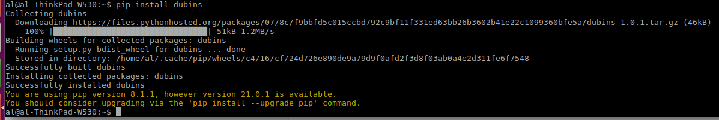
  - I don’t upgrade pip because I have had issues with it before.
- Copy path_generator.py to local machine
  - $ cd python # or whatever directory you want to store the script in
  - $ wget https://raw.githubusercontent.com/rje1974/Proyecto-Pochito/master/software/base/tractor/catkin_ws/src/pochito/scripts/path_generator.py

For each mission you want to plan:
- Create/Update a waypoint.txt file. Mine resides in /home/al/python
  - You have to choose a pattern you want to follow.
  - You will enter the waypoints into waypoint.txt which will serve as input to generate a more complex pattern and detailed listing of waypoints that will be stored in generated_points.txt
  - The format of the waypoint is x, y, ending yaw position in radians.
  - If you are making a turn, remember the x,y position is the start of the turn.
  - Below are some example patterns on the right created when the waypoints on the left were used as input.
  - At 12:31 in video lawntractorautomation on 2021-03-05 18-29.mp4 Jeff explains the concepts behind point placement and heading for this model: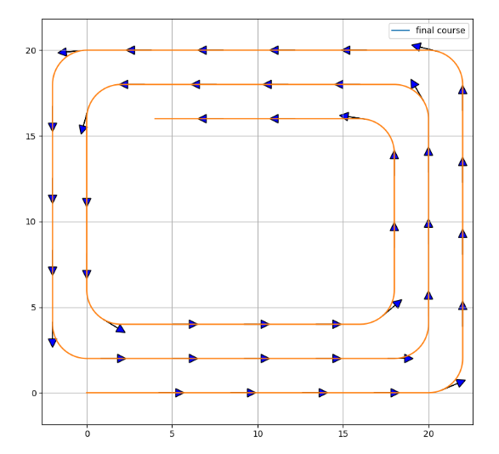
  - For direction, keep in mind, magnetic East = 0, mag. North = 1.57 (pi/2), mag. West = 3.14 (pi) and mag. South = 4.71 (pi+(pi/2))
  - The angle / ”Theta” is the angle the robot should be heading when it reaches that point.

Waypoints | Pattern
0.0 0 0  10.0 0 0  10.0 2 3.14  0.0 2 3.14  “Go East 10 meters, make a left turn, and return” | 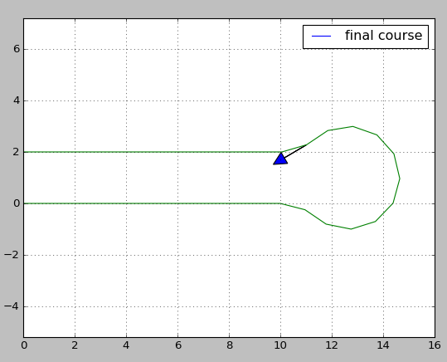
0.0 0 1.57  0 10 1.57  2 10 4.71  2 0 4.71  “Go North 10 meters, make a right turn, and return” | 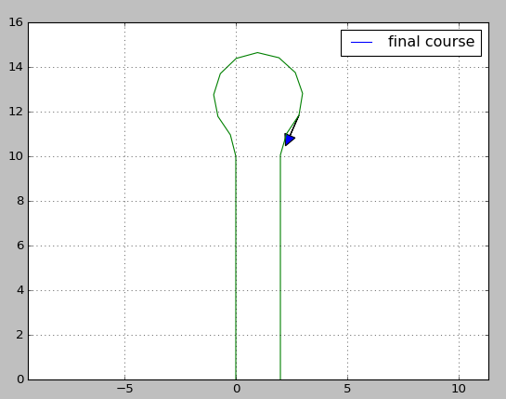
0.0 0 1.57  0 10 1.57  -2 10 4.71  -2 0 4.71  “Go North 10 meters, make a left turn, and return” | 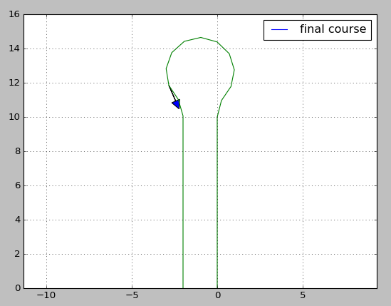
0.0 0.0 0.0  10.0 0.0 0.0  10.0 2.0 3.14  0.0 2.0 3.14  0.0 4.0 0.0  10.0 4.0 0.0  10.0 6.0 3.14  0.0 6.0 3.14 | 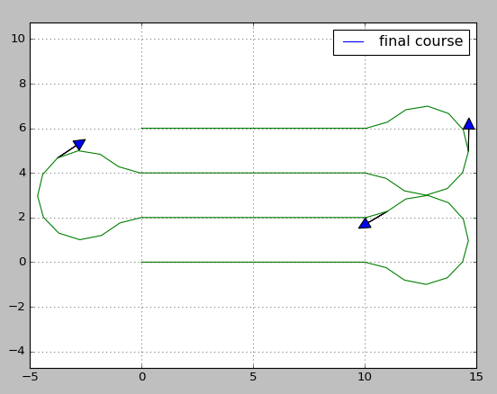
0.0 0.0 0.0  10.0 0.0 0.0  10.0 10.0 3.14  2 10 3.14  0 0 4.71  “Run a box route, starting East for 10 meters and return to the starting point” | 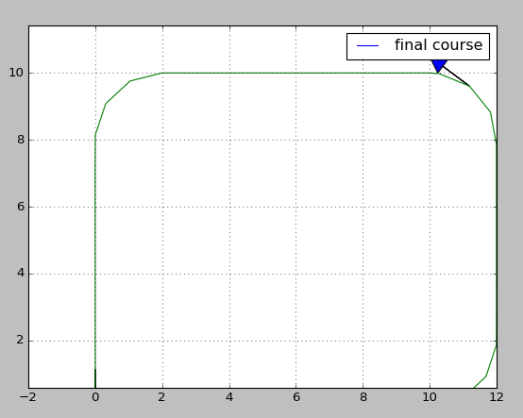
0 0 1.57  -2 10.0 3.14  -10.0 8 4.71  -8 0 0  0 0 0  “Run a box route, running North for 10 meters and return to the starting point” | 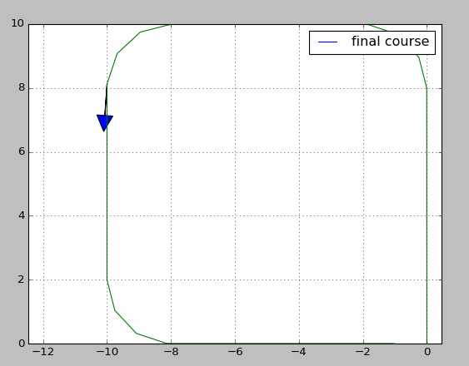
0 0 0  10 0 0  10 10 3.14  0 10 3.14  0 6 0  6 6 0  6 4 3.14  0 4 3.14 | 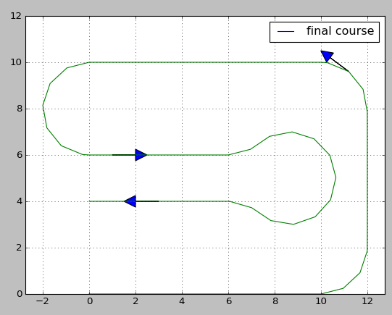
0.0 0.0 0.0  20.0 0.0 0.0  20.0 20.0 3.14  0 20 3.14  0 2 0  18 2 0  18 18 3.14  2 18 3.14  2 4 0  16 4 0  16 16 3.14  4 16 3.14  Notes from Jeff:  If you are doing a large area it behaves fairly well. (by just defining the horizontal rows) As long as you want your two spacing to match your turning radius. So the row spacing is 2 meters and the turning radius is set to 2 meters. You could set your radius to 3 meters but then you have to space your horizontal rows by 3 meters. Otherwise you would have to define both horizontal and vertical rows and use the more complex "stop short by 1 radius" method. | Credit: Jeff
-14 0 0  0 0 0  40 0 0  40 2.5 3.1415  0 2.5 3.1415  0 5 0  40 5 0  40 7.5 3.1415  0 7.5 3.1415  0 10 0  40 10 0  40 12.5 3.1415  0 12.5 3.1415  0 15 0  40 15 0  40 17.5 3.1415  0 17.5 3.1415  0 20 0  40 20 0  40 22.5 3.1415  0 22.5 3.1415  0 25 0  40 25 0  40 27.5 3.1415  0 27.5 3.1415  0 30 0  40 30 0  40 32.5 3.1415  0 32.5 3.1415  0 35 0  40 35 0  40 37.5 3.1415  0 37.5 3.1415  0 40 0  40 40 0  47 40 4.7123  47 1.25 4.7123  43.5 -2.25 3.1415  -2.5 -2.25 3.1415  -5 0 1.57075  -5 40 1.57075  0 42.5 0  40 42.5 0  42.25 40 4.7123  42.25 1.25 4.7123 | 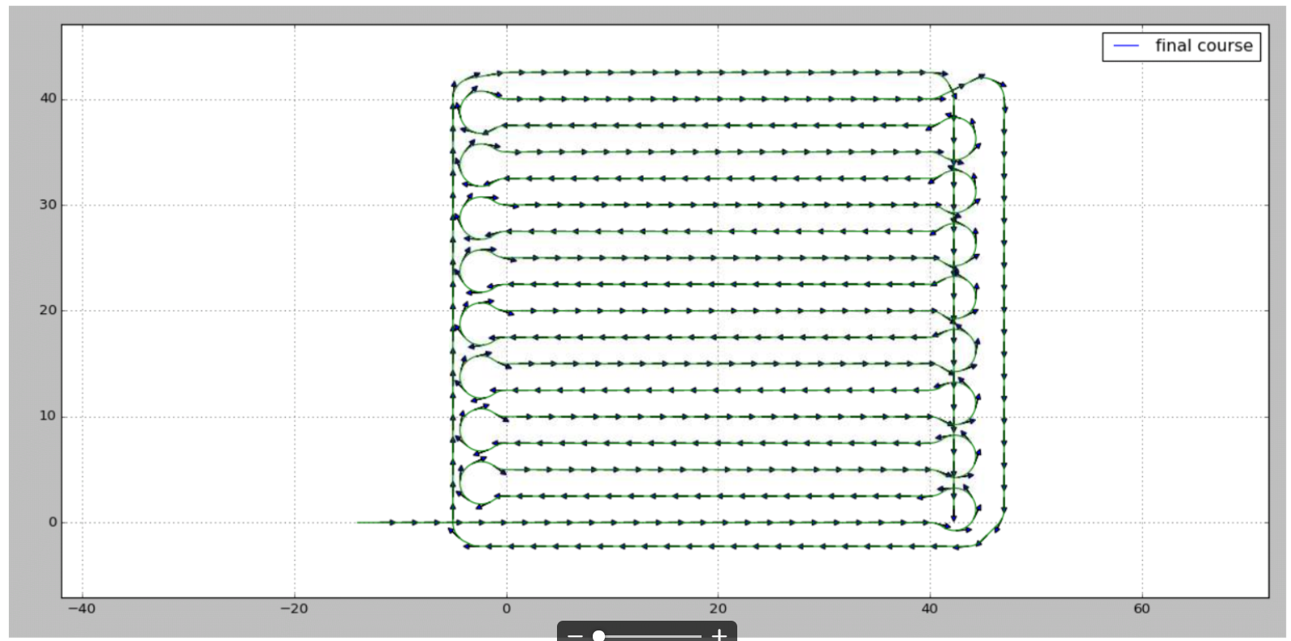  Credit: Juan

  - Formulate the input waypoints.
            - The vehicle_dimension spreadsheet has a tab “path_planner” that may be helpful to create an initial path
            - If you don’t know the angle you can use ‘~code_for_testing/archive/path_calc_angles_for_generator.py’ to help calculate them
  - Create a text file and insert the points; Start with a meaningful name. $ cd ~/ros1_lawn_tractor_ws/project_notes/code_for_testing/paths
  - $ nano 435_pine_valley_test1.txt
  - Open path_planning_waypoint_generator.py and update the input text file and the output file; Update the turning radius if needed.

Using the path just created:
  - Open publish_drive_path.py and update the filename with the latest output file name (e.g. "generated_waypoints.txt")
  - $ cd /home/tractor/ros1_lawn_tractor_ws/project_notes/code_for_testing/path_planner_stable
  - Create the waypoints by running $ python3 path_planning_waypoint_generator.py
  - Update path_generator.py line 48 with the location of that file (example below)

- Run script
  - Open Gazebo, Movebaseflex and RVIZ
  - Ctrl+Alt+T; $ cd /home/al/ros1_lawn_tractor_ws/src/ackermann_vehicle/nodes
  - $ python3 path_generator.py # jeff used $ python3 path_planner.py
  - If all goes well you should get similar results to the following:

  - Possible errors:
    - If you receive the message “IndexError: list index out of range”, check to make sure you don’t have blank lines at the end of the waypoint.txt file.
Using the generated waypoint file in the simulator:

Notes:
- This assumes you have already completed the one time steps laid out in the document “Using Matt's waypoint publisher with simulator running in Docker”.
- See “Update the max speed (max_vel_x in teb planner)” if you want to adjust the speed the vehicle will use as target speed.

- Copy the generated_points.txt to the correct location
  - FROM: /home/al/python # will vary based on your setup
  - TO: /home/al/python/runmission

Start rosagriculture/lawn_tractor, On physical laptop, connect gamepad and launch Docker
- Connect joystick
- Ctrl+Alt+T
- Right click, split window horizontally to make two windows, split again horizontal, then divide bottom window vertically
- 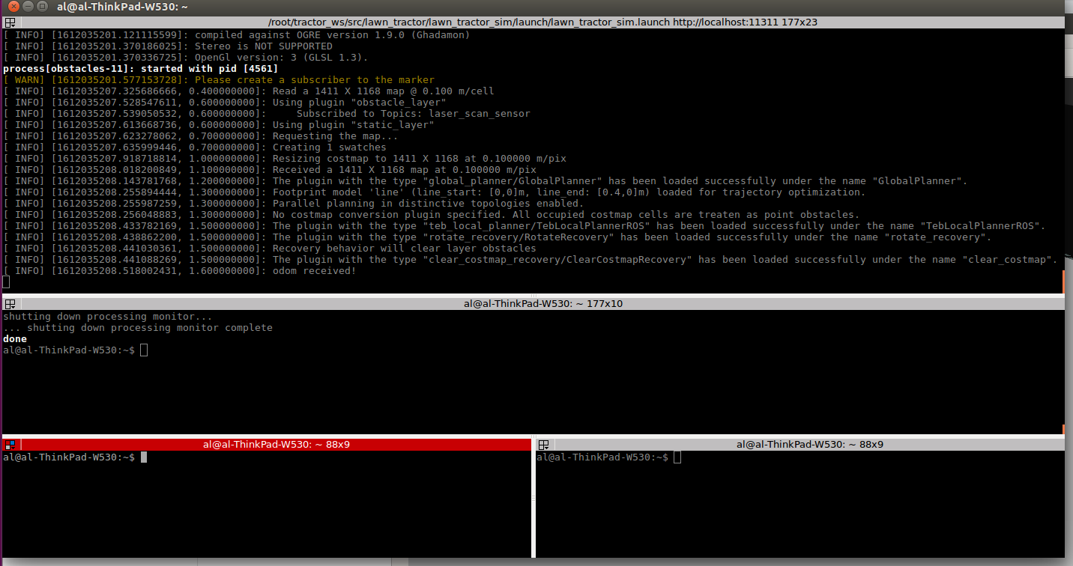
- Top horizontal, window 1: Launch Docker and rosagriculture/lawn_tractor simulator,
  - $ ./start.sh # I receive the response, “non-network local connections being added to access control list ”
  - # roslaunch lawn_tractor_sim lawn_tractor_sim.launch
- Next horizontal window 2: Launch teleop, $ roslaunch tractor_teleop drive.launch
- Window 3 (left):
- $ cd ~/python/runmission
- $ rosrun beginner_tutorials path_publisher.py
- Window 3 (right): $ rosrun beginner_tutorials path_follower_node.py

After you start path_follower_node.py the tractor should move according to the path created above.

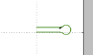

2/9/23 – trying to generate a cirlce similar to this:
New point 0 Going from 10.0,10.0 at 0 radians generates the new point (15.0, 10.0)
New point 1 Going from 10.0,10.0 at 1.047 radians generates the new point (12.5, 14.3)
New point 2 Going from 10.0,10.0 at 2.094 radians generates the new point (7.5, 14.3)
New point 3 Going from 10.0,10.0 at 3.142 radians generates the new point (5.0, 10.0)
New point 4 Going from 10.0,10.0 at -2.094 radians generates the new point (7.5, 5.7)
New point 5 Going from 10.0,10.0 at -1.047 radians generates the new point (12.5, 5.7)

Where the entry point of the circle will be near (5,10);

Waypoints | Pattern
0.0 0 0
10.0 0 0
10.0 2 3.14
0.0 2 3.14

“Go East 10 meters, make a left turn, and return”
0.0 9.9 0  5.8 9.9 0  5.8 10.1 3.14  0.0 10.1 3.14  turning_radius = 2.5  step_size = 2.0  Trying to get as close to the circle I built | 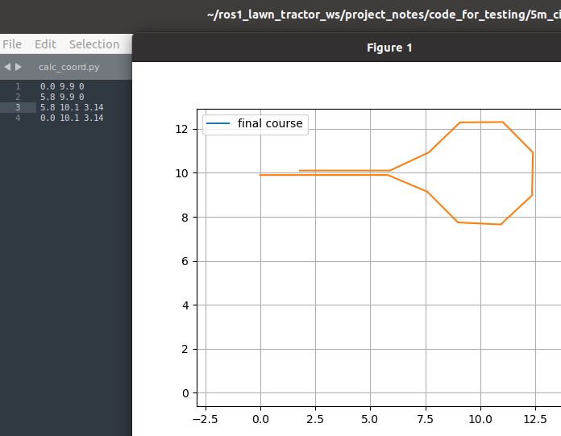

Other notes:

Background video on dubins path by Kyler Laird. The code referenced in the video.

Notes from a previous conversation re: 3 navigation choices
- Link to 03132020 Lawn Tractor Meeting:
- https://www.youtube.com/watch?v=Cp1qO2Kcf-g
  - 29:36 “this planner will try to plan too tight of a turn tight of turn angle”
  - Move base
  - Move base flex which is New planner Vinnie is working on; If you wanted to have ROS obstacle avoidance; Will allow a predefined path to be sent in
  - Ag Bot version uses Pure Pursuit - under Ag Bot Base - setup instructions in a Google Doc - No obstacle detection, a little dumb, publish a nav message path; doesn’t have obstacle layers, start the pure pursuit controller, then it will try and the pure pursuit controller will try to read that path and try to drive your robot
  - 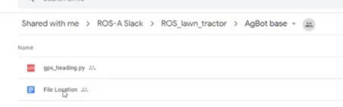

Jeff’s notes:
I loaded it and ran it under python3, so it does work under python3 also.
I copied it into my home directory. I had to load "dubins". pip3 install dubins
I had to change the path for the "waypoint.txt" input file. I just made up a random waypoint file. And ran it. I was surprised that it created a graph for me.
It also created a "generated_points.txt" output file.

